2400040454.
Harsha vardhan
EXPERIMENT: DATA VISUALIZATION USING POWER BI
AIM: To create simple interactive excel dashboard for given data using POWER BI desktop.
Outcomes: Students are able to understand basics of POWER BI and create simple dashboard using POWER BI desktop application.
Apparatus/Software required: data sheet in .xls or CSV format, POWER BI desktop, System/laptop with minimum specifications.
Procedure:
1. Read the data for which visualization to be done.
2. Clean the data which includes deleting, filtering and rearranging of raw data whichever necessary.
3. Open POWER BI app by double clicking on icon or right click on icon and press open. Wait till model initialize.
4. Once the POWER BI is open you can log in to the account through Microsoft credentials
5. Import the data either from excel or csv file. In this example we will import two excel files which are of covid 19 state wise data and state wise test sample details.
6. To import data click on get data option which available on home tab and select file type.
7. Click on type of file and it will ask location from which file to be uploaded. Now select the file and click on open.
8. After clicking open, Navigator popup which will ask to select particular sheet from the sheet. Select raw data and click on transform data.
8. After clicking on transform data we will get window caller power query editor in which we can manipulate data. Check all data are visible or not and edit if required only.
9.Once edit or transforming has done then click on close and apply button from left fop corner which is mandatory to apply the changes made in data.
10. Ensure all information is imported properly or not from right side fields.
11. Now the POWER BI engine is ready to create dashboard. Initially name the dashboard “ COVID 19 DETAILS INDIA”. By selecting put text box and restyle it as per requirement.
12. Now on the dashboard we have blank bar chart with fields to be assigned.
13. Interactive dash board is ready with 4 different visualizations.
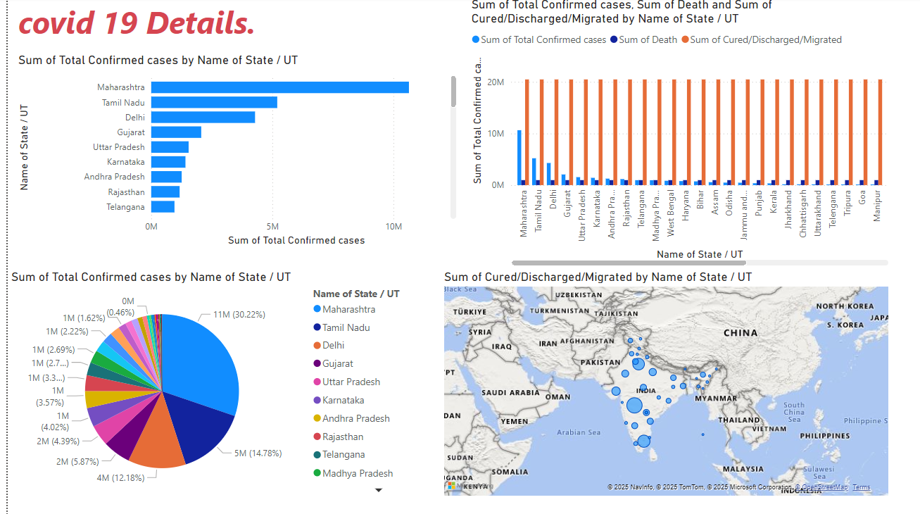
RESULT: Simple interactive dashboard I POWER BI created.

